ASSIGNMENT 6.3
NAME: Karthikeya Uthuri HALLTICKETNO: 2303A51306 BATCH: 05
TASK1:
Scenario
You are developing a simple student information management module. Task
- Use an AI tool (GitHub Copilot / Cursor AI / Gemini) to complete a Student class.
- The class should include attributes such as name, roll number, and branch.
- Add a method display_details() to print student information.
- Execute the code and verify the output.
- Analyze the code generated by the AI tool for correctness and clarity.
PROMPT:Create a Python Student class with attributes name, roll_number, and branch. Add a method display_details() to print the student information.
Create a sample object, call the method, and show the output. Also give a short analysis of the code.
OUTPUT:
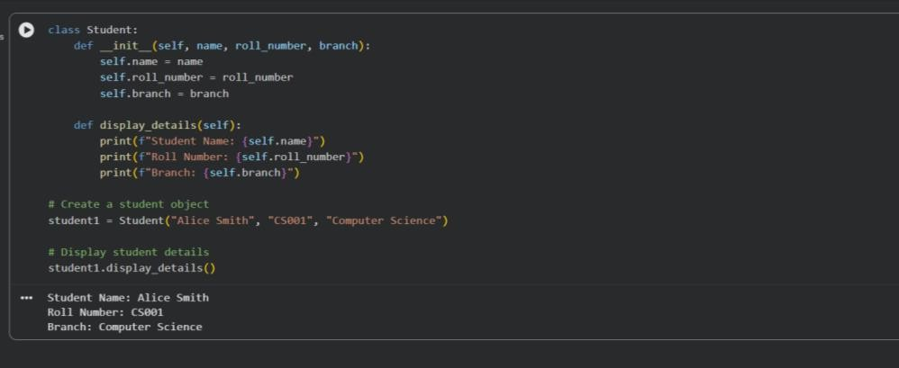

TASK 2:
Scenario
You are writing a utility function to display multiples of a given number. Task
- Prompt the AI tool to generate a function that prints the first 10 multiples of a given number using a loop.
- Analyze the generated loop logic.
- Ask the AI to generate the same functionality using another controlled looping structure (e.g., while instead of for)
PROMPT: Write a Python function that prints the first 10 multiples of a given number using a for loop. Explain the loop logic briefly

OUTPUT:

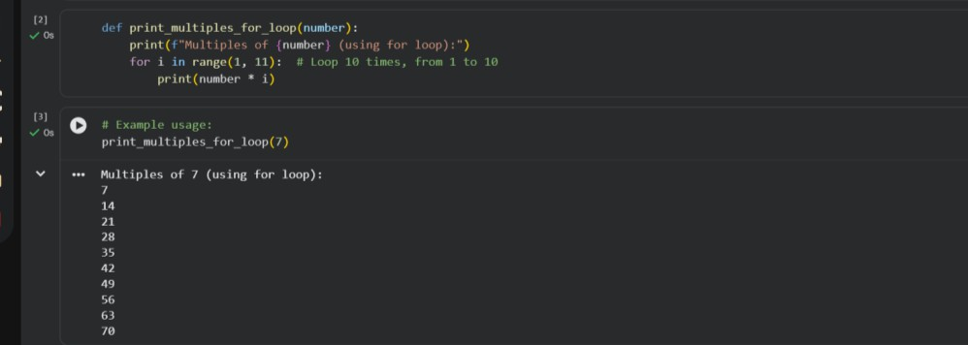

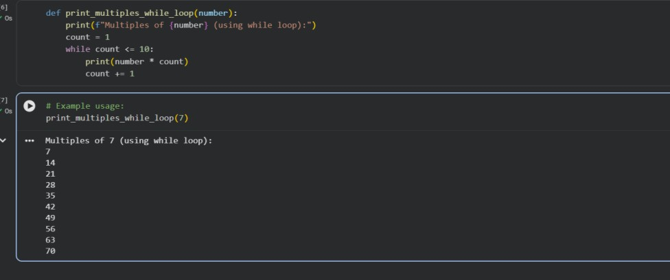

Task Description #3: Conditional Statements (Age Classification) Scenario
You are building a basic classification system based on age. Task
- Ask the AI tool to generate nested if-elif-else conditional statements to classify age groups (e.g., child, teenager, adult, senior).
- Analyze the generated conditions and logic.
- Ask the AI to generate the same classification using alternative conditional structures (e.g., simplified conditions or dictionary-based logic)
PROMPT:
Write a Python program that classifies a person based on age using if–elif–else statements (child, teenager, adult, senior
OUTPUT:

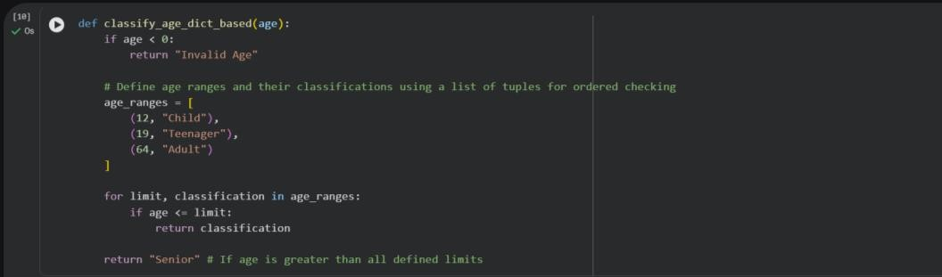
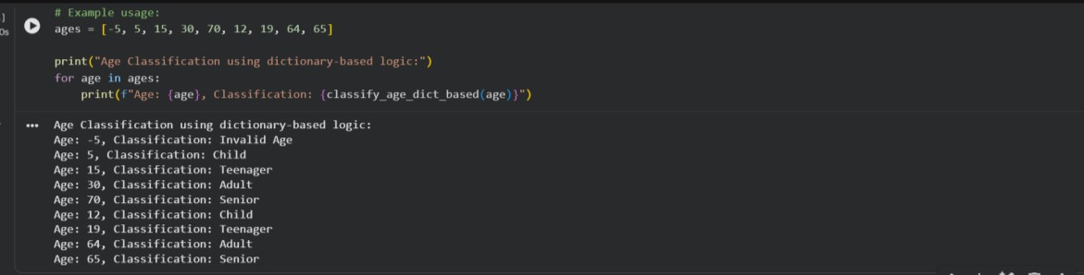

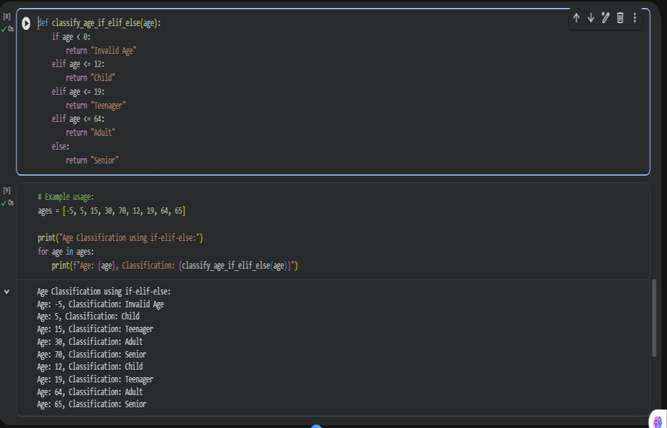
Task Description #4: For and While Loops (Sum of First n Numbers) Scenario
You need to calculate the sum of the first n natural numbers. Task
- Use AI assistance to generate a sum_to_n() function using a for loop.
- Analyze the generated code.
- Ask the AI to suggest an alternative implementation using a while loop or a mathematical Formula
PROMPT:
Write a Python function sum_to_n(n) that calculates the sum of the first n natural numbers using a for loop.
Display the result and explain the code briefly
OUTPUT:

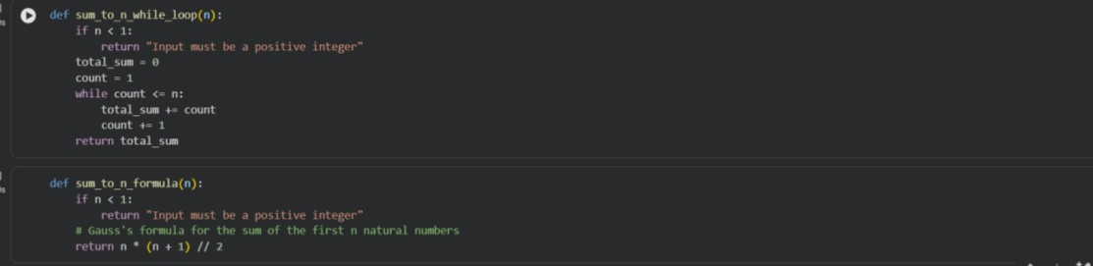

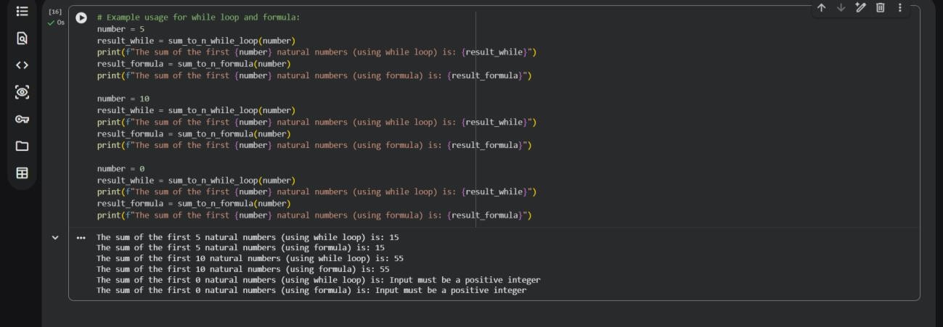

Task Description #5: Classes (Bank Account Class) Scenario
You are designing a basic banking application. Task
- Use AI tools to generate a Bank Account class with methods such as deposit(), withdraw(), and check_balance().
- Analyze the AI-generated class structure and logic.
- Add meaningful comments and explain the working of the code PROMPT:
Create a Python BankAccount class with attributes like account_number and balance. Add methods deposit(), withdraw(), and check_balance().
Show sample object creation and method calls OUTPUT:

